NAAN MUDHALAVAN PROJECT:

**ESTIMATION OF BUSINESS EXPENSES**

TEAM :

P.VAITHEESWARI

T.DALCIYA

R.ARTHI

S.GAYATHRI

OVERVIEW:

INTRODUCTION:

This report delves into the fascinating realm of business expenses and provides a visual exploration of the various expenditures incurred by different businesses. It showcases the distribution of expenses, identifies key cost drivers, and highlights areas of potential optimization or concern. The visual representations allow for intuitive analysis, facilitating a deeper understanding of expenditure patterns and their implications for business performance. Decision-makers, financial analysts, and stakeholders can gain valuable insights into the financial health of businesses, identify areas of inefficiency or opportunity, and make informed decisions to optimize resources and drive growth. To Extract the Insights from the data and put the data in the form of visualizations, Dashboards and Story we employed Tableau tool.

PURPOSE:

Estimates are important because they allow businesses to set expectations for their customers. They also help business determine whether or not a project is feasible and how much profit they can expect to make. Estimating also allows business to plan for unforeseen expenses and keep track of spending.

PROBLEM DEFINITION AND DESIGN THINKING:

1.EMPATHY: 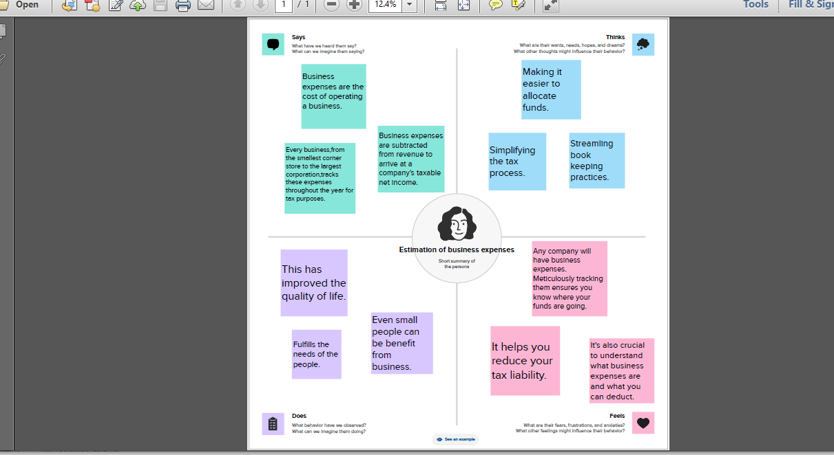

2.IDEATION AND BRAINSTORMING MAP:

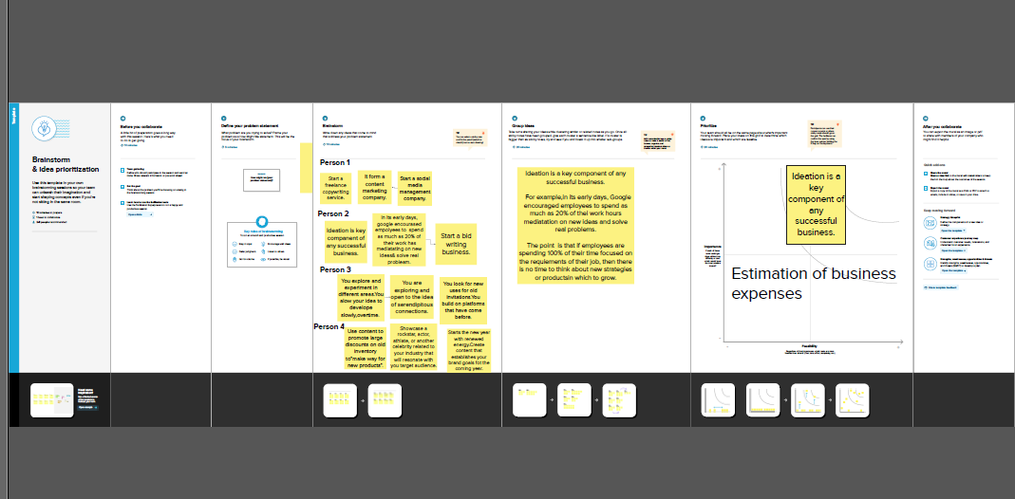

ADVANTAGE:

Cost estimation is an its of mation indispensable process that provides numerous benefits to project management. These benefits include budget planning, resource allocation, risk management, improved decision-making, and competitive advantage.

DISADVANTAGES:

Financial Risks. A business requires an extensive amount of financial resources to launch and expand. ...

Time Commitment. ...

Dealing with Stress. ...

Risk of Failure. ...

High Competition. ...

Possible Lack of Guidance. ...

Lack of Business Processes and Operational Procedures.

APPLICATION:

A formula for calculating expenses in a business is: Total Expenses = Cost of

Goods Sold (COGS) + Operating Expenses. Vakilsearch can assist you in understanding the legal and regulatory requirements related to business expenses, ensuring compliance and smooth operations.

CONCLUSION:

In conclusion, cost estimation is an important component of project management that ensures projects are finished on schedule and within budget. Since inaccurate cost estimates can have serious financial consequences for businesses, accurate cost estimating is crucial for all stakeholders engaged in a project.

FUTURE SCOPE:

This involves estimating all the expenses required to start and operate the business, such as equipment, rent, inventory, and marketing. By calculating these costs upfront, business owners can better plan their budget and avoid unexpected expenses.